Serverless Image Resizer & Logger using Amazon S3 and AWS Lambda

📌 Project Overview
This project demonstrates a serverless image processing system where:
- Users upload images to an S3 bucket
- A Lambda function is automatically triggered
- The image is resized
- The resized image is stored in another S3 bucket
- Execution details are logged into CloudWatch
This architecture removes the need for server management and enables automatic scaling.

🏗️ Architecture Diagram

Flow Explanation
- User uploads image to Upload Bucket
- S3 generates an event notification
- Lambda function is triggered
- Image is resized
- Resized image is stored in Resize Bucket
- Logs are stored in CloudWatch
This is an example of event-driven architecture.
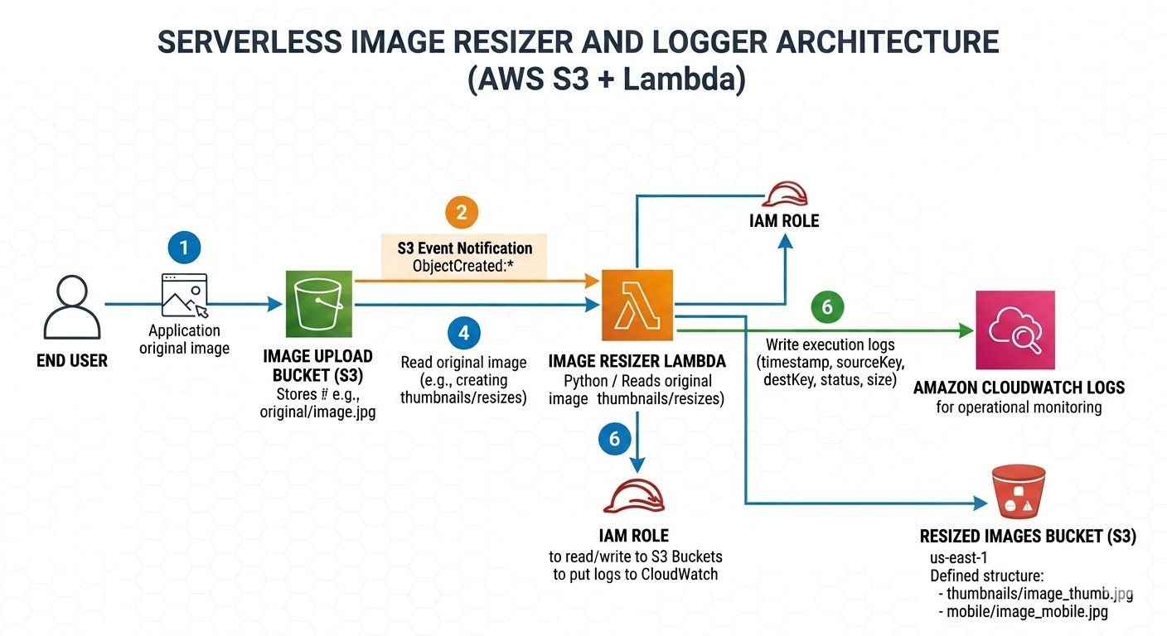

Step 1: Create Resize Bucket

Bucket Name:
Satya-image-upload

Configuration:
- Region: Same region as Lambda
- Enable Versioning
- Block all public access
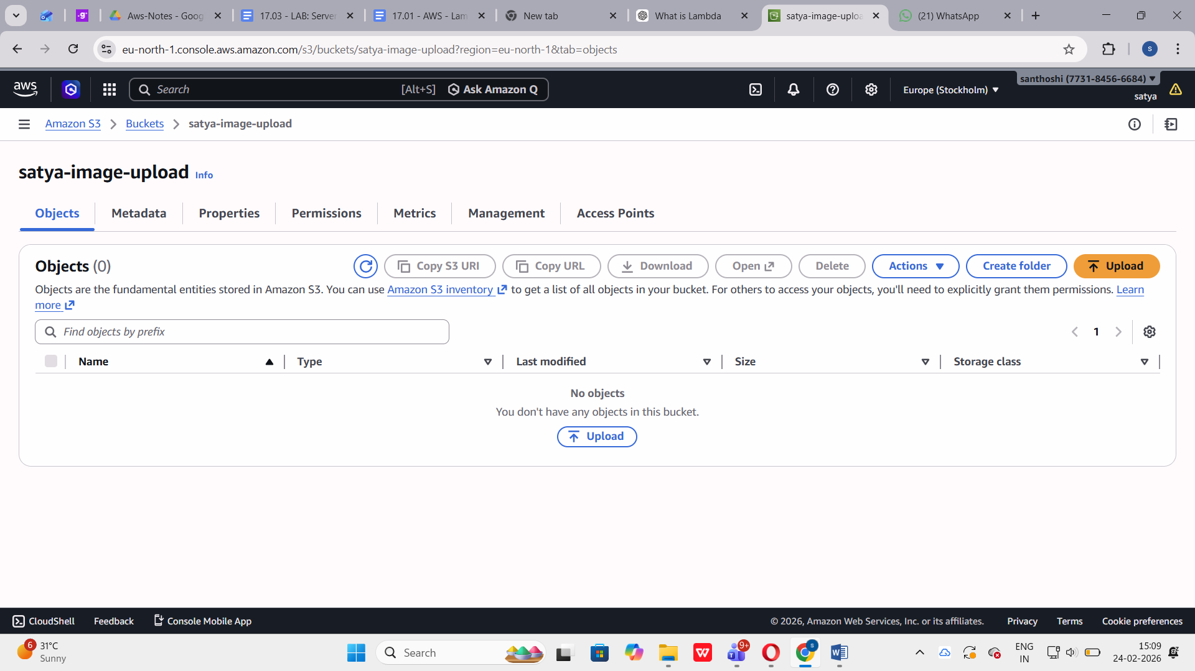

Step 2: Create Upload Bucket

Bucket Name:
Satya-image-upload2

Configuration:
- Region: Same as Lambda
- Enable Versioning
- Block all public acces
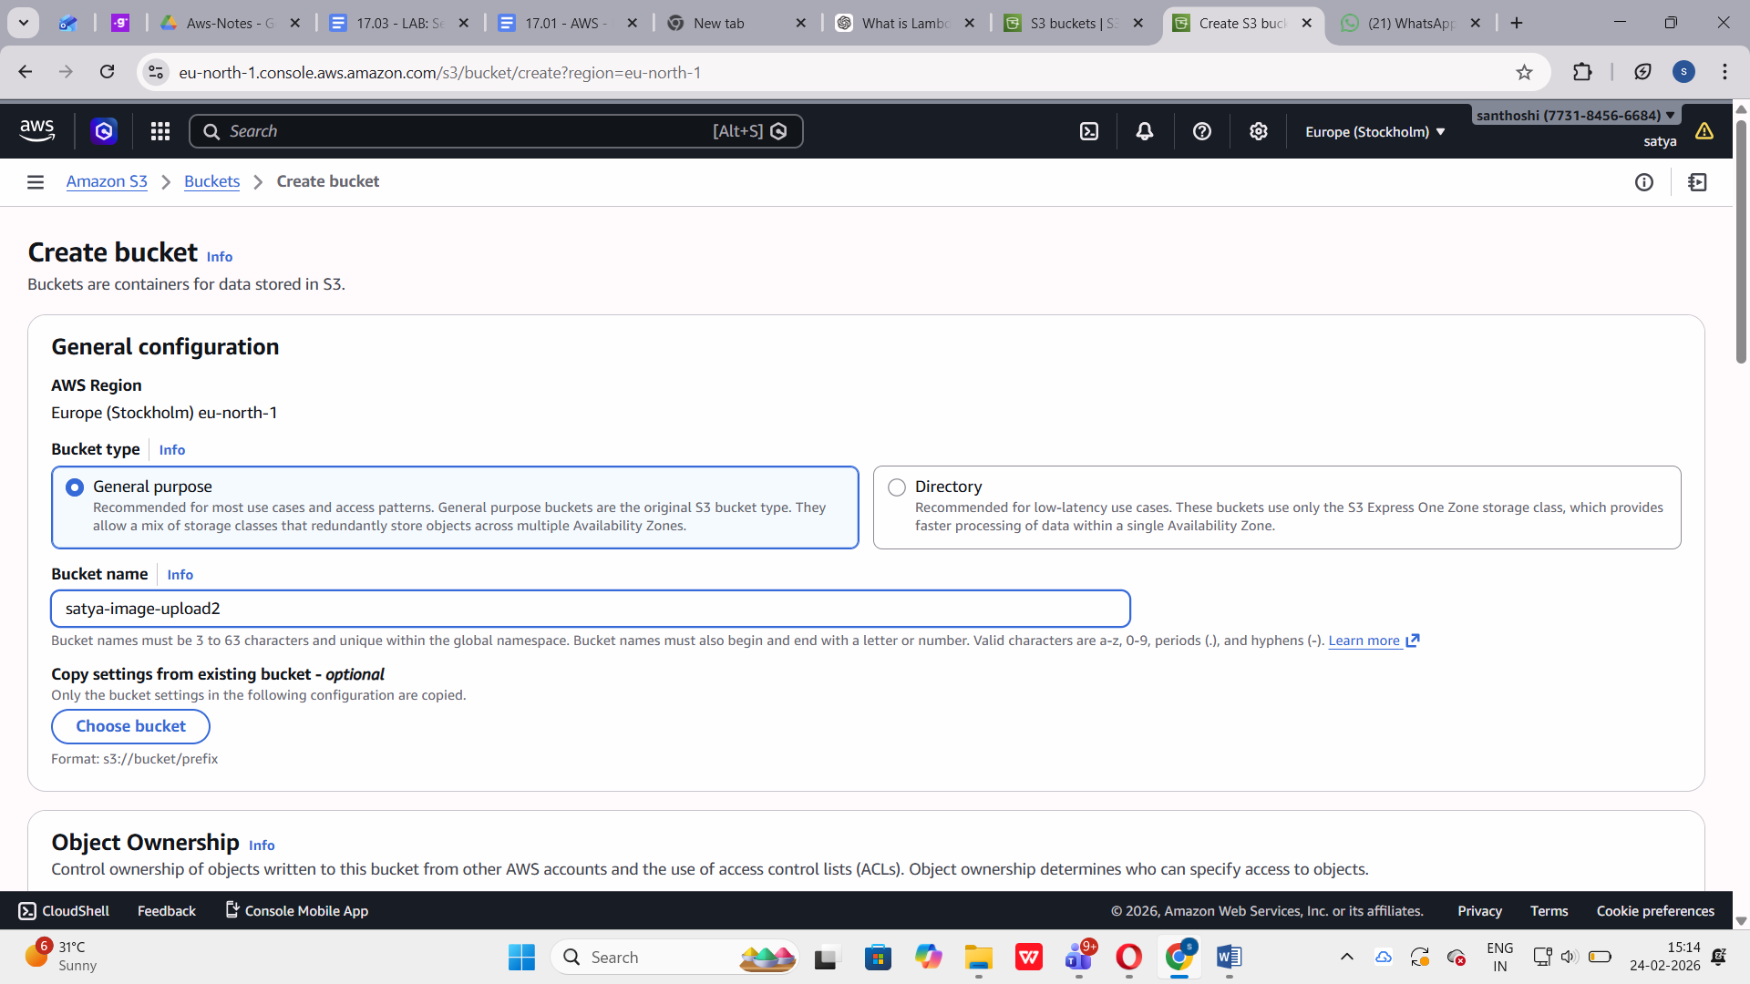

Why Enable Versioning?
Versioning protects files from:
- Accidental deletion
- Overwriting
Old versions can be recovered easily.

Why Block Public Access?
Blocking public access ensures:
- Images are not publicly exposed
- Secure internal processing
- Follows AWS security best practices

Step 3: IAM Role Creation (Least Privilege)
To allow Lambda to interact with AWS services, an IAM role is created.

Role Name:
Lambda-image-role

Trusted Entity:
AWS Lambda

Required Permissions:
- Read access from upload bucket
- Write access to resize bucket
- Permission to write logs in CloudWatch
- 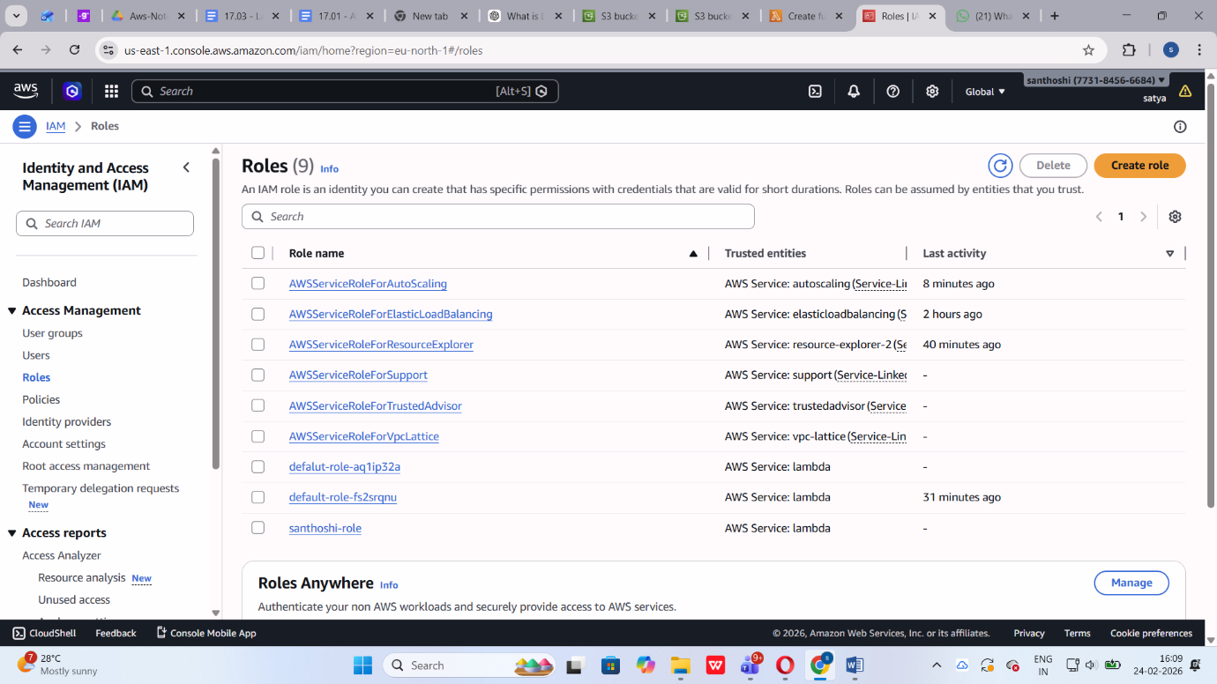
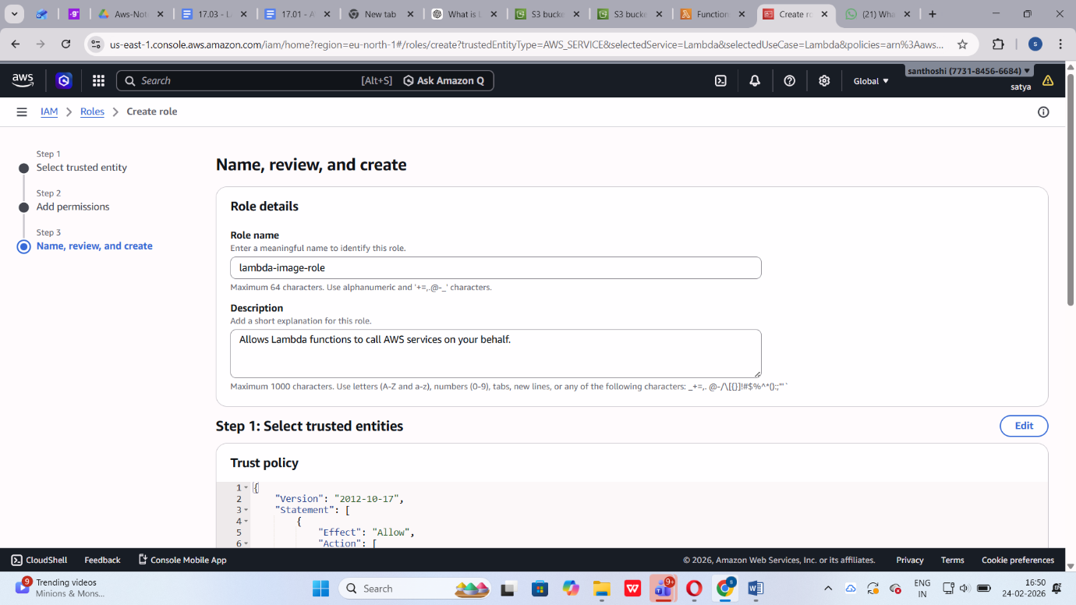

Step 4: Create Lambda Function
Navigate to:
AWS Lambda → Create Function

Configuration:
- Author from scratch
- Function Name: image resizers
- Runtime: Python 3.11
- Execution Role: Use existing role
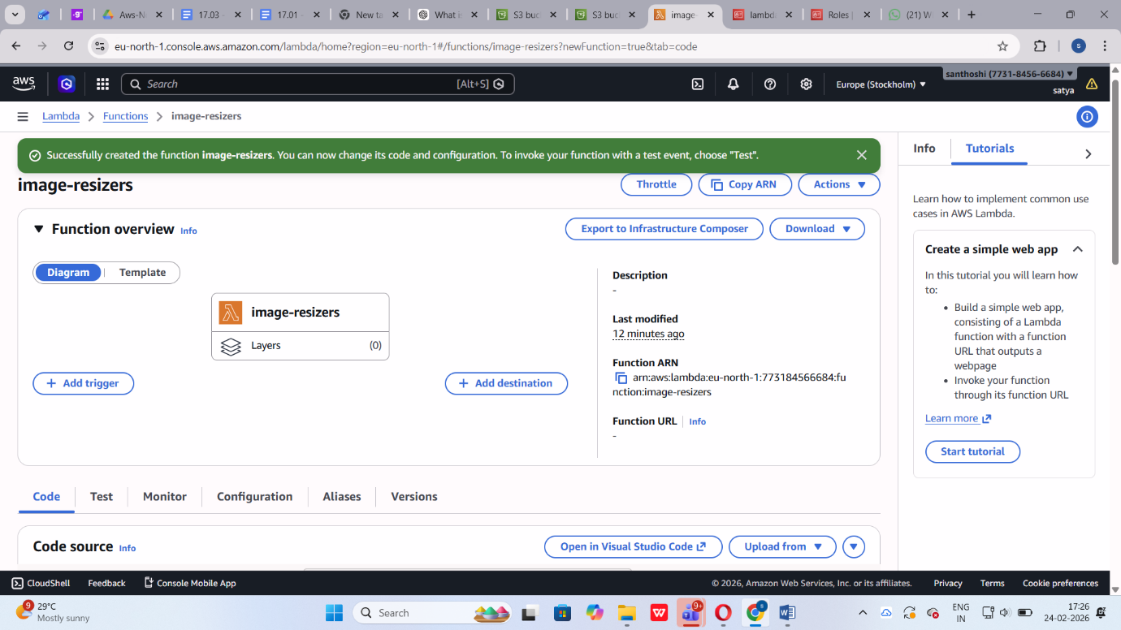

Step 5: Lambda Function Code
⚠ Pillow library must be added using a Lambda Layer.
import boto3
from PIL import Image
import io
import urllib.parse
s3 = boto3.client('s3')
DEST_BUCKET = "santhoshi-resize"
def lambda_handler(event, context):
print("Event received:", event)
for record in event['Records']:
source_bucket = record['s3']['bucket']['name']
object_key = urllib.parse.unquote_plus(
record['s3']['object']['key']
)
print("Source bucket:", source_bucket)
print("Object key:", object_key)
response = s3.get_object(
Bucket=source_bucket,
Key=object_key
)
file_content = response['Body'].read()
image = Image.open(io.BytesIO(file_content))
image.thumbnail((300, 300))
buffer = io.BytesIO()
image.save(buffer, format="JPEG")
buffer.seek(0)
resized_key = "resized-" + object_key
s3.put_object(
Bucket=DEST_BUCKET,
Key=resized_key,
Body=buffer,
ContentType="image/jpeg"
)
print("Resized image uploaded:", resized_key)
return "Processing Complete"

Step 6: Configure S3 Trigger
To automate the process:
- Open Lambda
- Click Add Trigger
- Select S3
- Bucket: santhoshi-upload
- Event Type: PUT
- Suffix:
- Save
Now, whenever a .jpg file is uploaded, Lambda runs automatically.
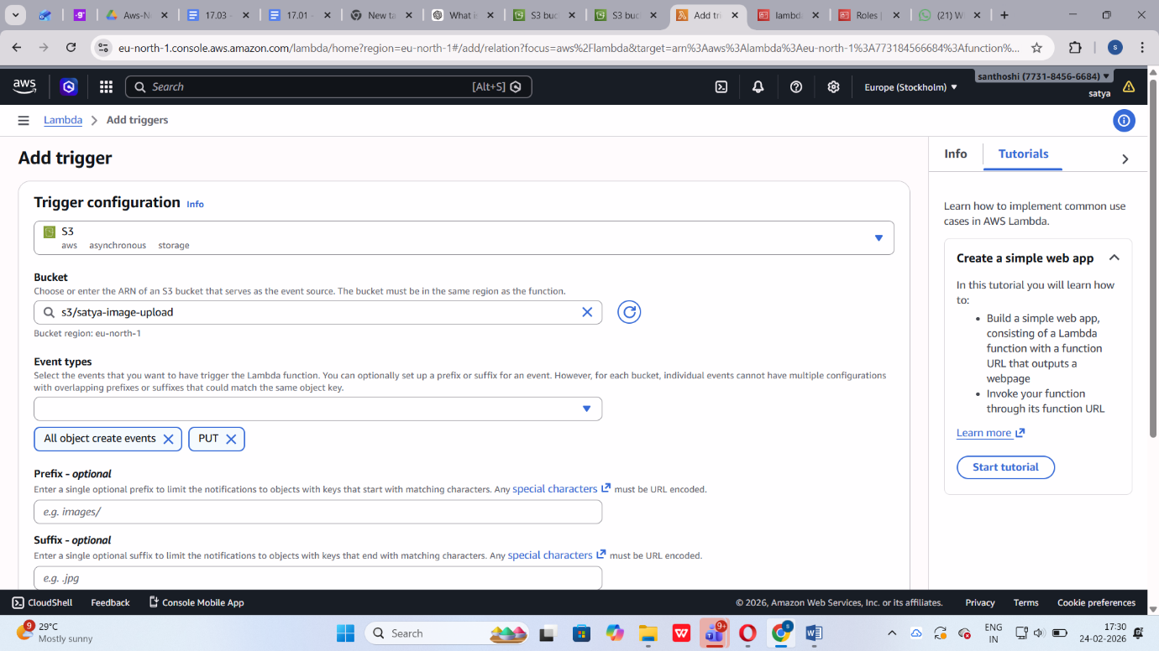

Step 7: Create Lambda Layer (Pillow Library)
Since AWS Lambda does not include Pillow by default:
- Go to Lambda → Layers
- Click Create Layer
- Upload pillow-layer.zip
- Compatible Runtime: Python 3.11
- Create Layer
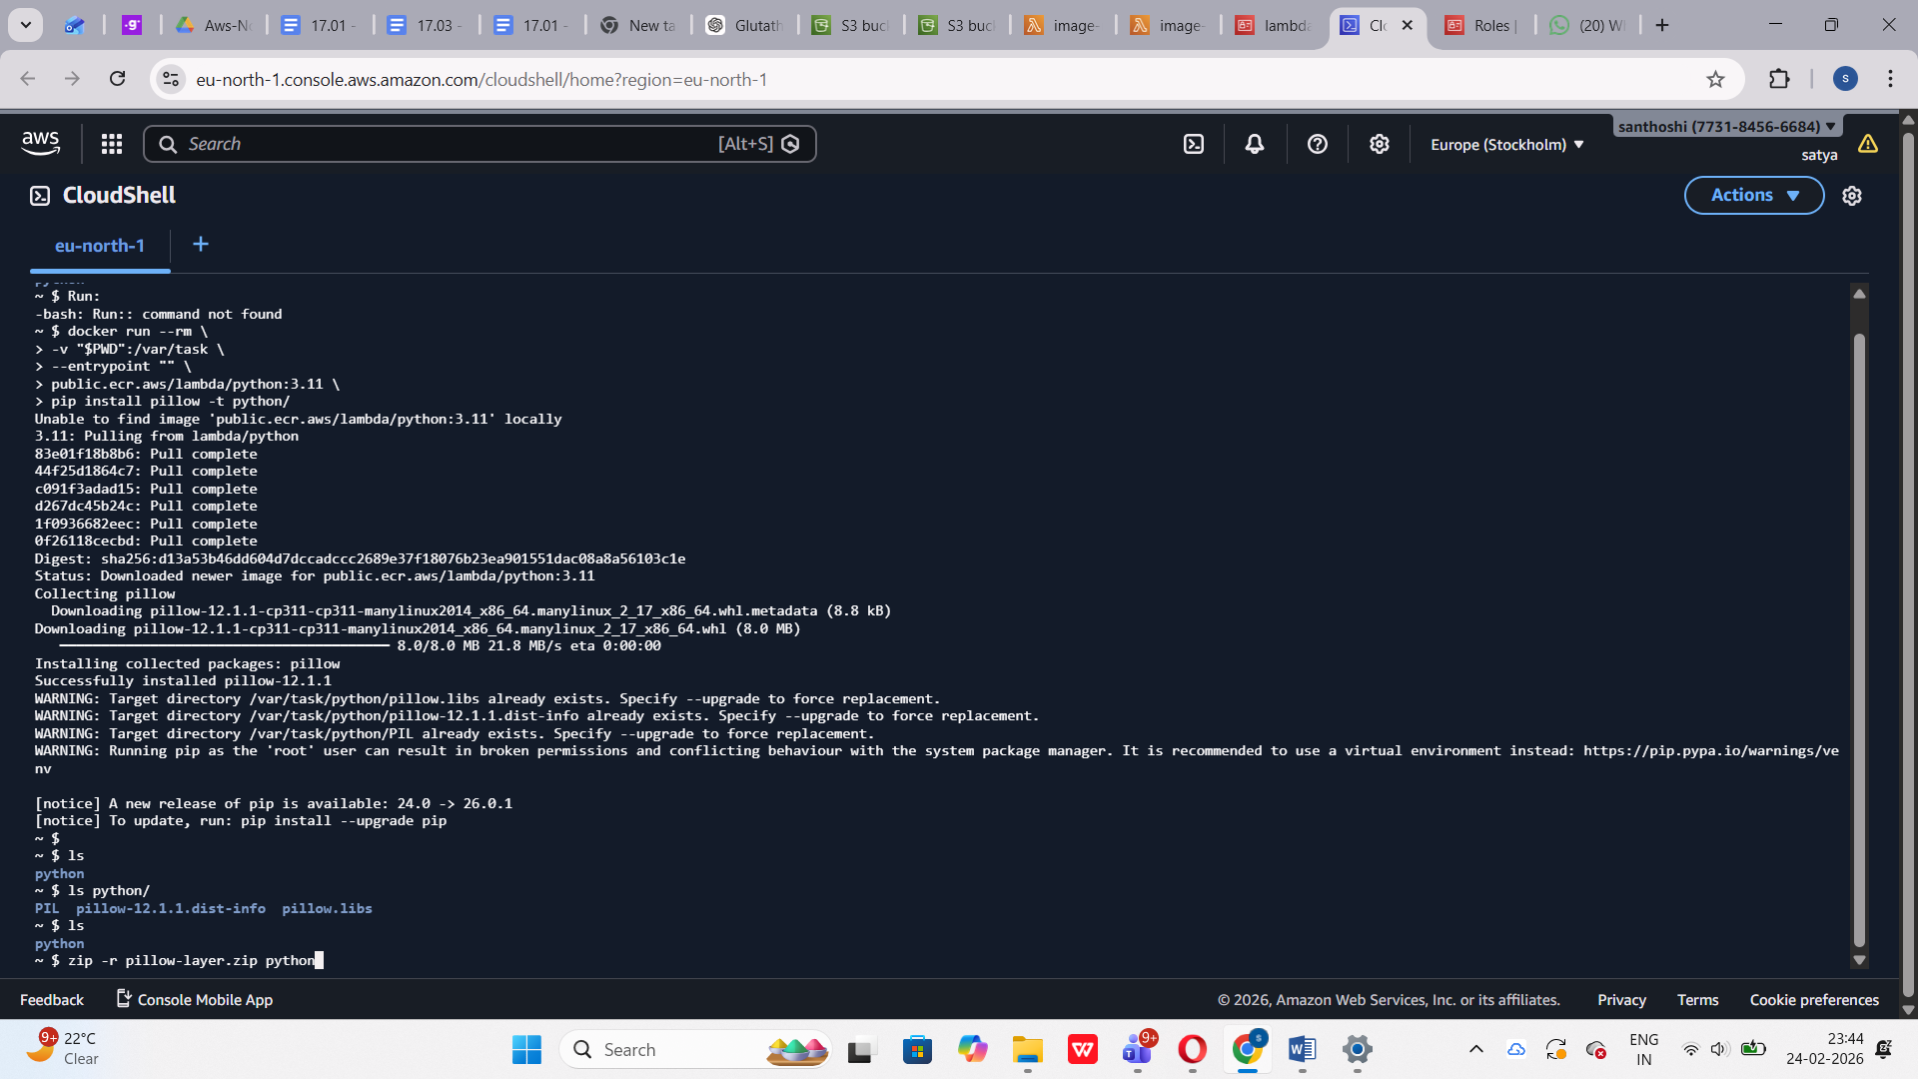
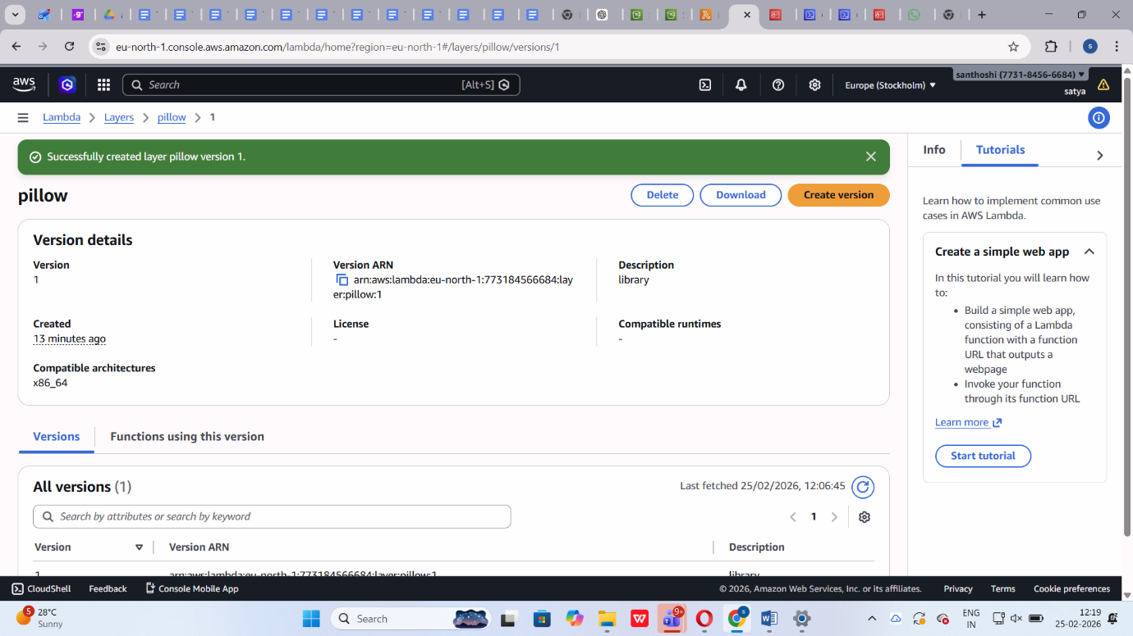

Step 8: Attach Layer to Lambda
- Open Lambda → santhoshi
- Scroll to Layers
- Click Add Layer

Step 9: Testing the Solution
Upload test file:
- image1.jpg
Upload into:
Satya-image-upload bucket
Expected Result:
- Resized image created in satya-image-upload2
- File name: satya-image-upload2

Step 10: CloudWatch Log Verification
- Go to CloudWatch
- Open Log Groups
- Select Lambda log group
- Verify execution logs
Logs should show:
- Event received
- Image resized
- Upload success message
📸 Insert Screenshot Here – CloudWatch Logs

How the System Works (Short Explanation)

Why use Lambda for image processing?
Lambda is serverless. It runs only when an image is uploaded. There is no need to manage servers, and it automatically scales based on demand.

What happens if multiple images are uploaded?
Lambda automatically scales horizontally. Each upload triggers a separate execution instance. AWS handles concurrency automatically.

How does S3 trigger Lambda?
When an object is uploaded, S3 generates an event notification. This event contains metadata like bucket name and file key. The event is sent to Lambda, which processes the image.

Conclusion
This project successfully demonstrates:
- Event-driven serverless architecture
- Automatic image resizing
- Secure bucket configuration
- IAM-based access control
- Logging and monitoring using CloudWatch
The system is scalable, secure, and fully automated.

